**SMART HEALTH MONITORING SYSTEM FOR OLD PEOPLE**

**TARP Report**

*Submitted in partial fulfillment of the*

*requirement for the course of*

**TECHNICAL ANSWERS FOR REAL WORLD PROBLEMS**

**IN**

**ELECTRONICS AND COMMUNICATION ENGINEERING**

*By*

*Shaik.Aakhil Ahned-17BE1045*

*Sai Sundar-17BEC1048*

*Devapatla.Charan-17BEC1208*

*Patelkana.Karthik-17BEC1142*

*M.B.V. Sri Harsha-17BEC1195*

*Veldandi. Shiva Sai-17BEC1216*

*Kamineni.Mounish Naidu-17BEC1153*

*K.Madhusekhar-17BEC1124*

*To*

**Associate Professor**

**Sri. Om Prakash Saho**



**School of Electronics Engineering**

**VIT - Chennai**

**CHENNAI – 600127, Tamil Nadu, India**

*April 2020*

**ABSTRACT**

The leading edge of baby boomer (those people born worldwide between 1946 and 1964) generation started turning 65 in 2011. In the INDIA, over 10,000 baby boomers a day are turning 65 and the number of seniors is expected to double by the year 2050, to 80 million – and most of that growth started in 2010 and will continue until 2030, when the baby boom generation enters their senior years. [The U.S. Census Bureau](https://www.census.gov/population/socdemo/statbriefs/agebrief.html) predicts that the number of seniors will grow by an average of 2.8% a year during that time.  In Canada, seniors are expected to comprise [a quarter of the population by 2041](http://www.elections.ca/content.aspx?section=res&dir=rec/part/sen&document=index&lang=e).So this is a market that’s only going to get bigger, providing ever [more business opportunities](https://www.thebalancesmb.com/small-business-info-4161643) for those able and willing to meet their needs. Most people age 65 or over live at home, either with a spouse or alone. According to research by the [American Association of Retired Persons (AARP)](http://www.aarp.org/)nearly 90% of seniors wish to continue to live independently by staying in their own homes and communities. Unfortunately, many seniors have a disability or activity restriction that requires them to seek assistance with various activities. [Chronic health conditions are widespread among seniors](http://www.elections.ca/content.aspx?section=res&dir=rec/part/sen&document=index&lang=e), with four out of five seniors residing at home having a chronic health condition of some kind.  The most common of these conditions are arthritis or rheumatism, hypertension, (non-arthritic) back pain, heart disease and cataracts. A lot of seniors have the fear that if they fall, the recovery will take a long time and they will not be able to move around as before. It can result in a lack of mobility, causing depression and other serious conditions that can put the patient in a downward spiral. So we came up with a idea of developing a smart monitoring system for this above mentioned people, to help them carry on their day to day activities more independently. And gift them with a better life.

**INTRODUCTION**

An important part of our life, internet has enabled many machines and devices we use in everyday life to be monitored and controlled remotely through Internet of Things (IOT) technology. Thanks to IOT technology, smart health applications have become a rapidly growing sector. For individuals with heart disease, the Heart Rate (HR) and Body Temperature (BT) and their probability of falling are considered vital signs that must be measured regularly. In this study, a software-based application is developed that can monitor HR, HRV ,body temperature and fall detection parameters for dependent patients who should be under constant observation. The measuring system, which consists of wearable sensors, constantly measures patient signs. Then send the measured signals to registered devices via wireless connection. If the predetermined critical values for the patient are exceeded, the HR, body temperature fall detection probability of patient is sent both to family members and doctor as e-mail and mobile notification. Further we also have incorporated this device with fall detection technique and a panic button which immediately alerts the keens by sending a message via mail. The wearable measurement system allows patients to be mobile in their own social environment, allowing them to live their lives in confidence.

**MOTIVATION FOR THE PROJECT**

The elderly Indian population is one of the fastest growing in the world. **At 110 million, India has the second largest global population of ageing citizens.** By 2050, this number will probably increase to 240 million. However, India lacks the basic infrastructure and expertise to support the health and welfare of the elderly.

According to multiple surveys across the country, for most Indian senior citizens, the biggest concerns are**: healthcare costs, lack of financial support and isolation.** Additionally, most of the aged are not accorded the dignity of care they deserve.Lack of physical infrastructure is a major deterrent to providing comfort to the aged. There are few purpose-built care homes or even public ramps available for the less mobile older citizens, like those who need wheel chair access. With increasing longevity and debilitating chronic diseases, many elder citizens will need better access to physical infrastructure in the coming years. This will be both in their own homes and in public spaces, like roads and malls .Very little information and knowledge exists about specific geriatric diseases. Mental health issues are rarely discussed and the country is ill-prepared to deal with the increasing incidence of dementia, Alzheimer's and depression amongst the elderly. There are few facilities and experts who can manage geriatric health effectively, even in major metros.

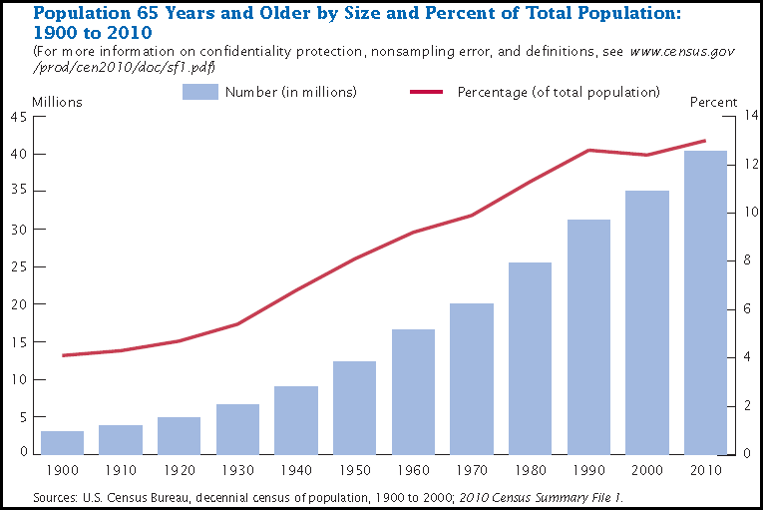

Unlike most developed countries, emergency response infrastructure for senior citizens is ill-developed, including the availability of public ambulances for hospitalisation. One of the biggest fears for most senior citizens living alone is how to go about accessing an emergency facility if required, especially at night.

Rapid socio-economic change, including more nuclear families, is also making elder care management difficult, especially for busy adult children responsible for their older parents' wellbeing. Managing home care for the elderly is a massive challenge as multiple service providers, who often do not talk to each other, are involved in providing that care. These include nursing agencies, physiotherapists and medical suppliers. Most of these providers are small, unorganised players who extend sub-optimal care. Most senior citizens who live alone suffer due to lack of companionship

**OBJECTIVE**

Health monitoring is the major problem in today’s world. Due to lack of proper health monitoring, patient suffer from serious health issues. There are lots of IOT devices now days to monitor the health of patient over internet. Health experts are also taking advantage of these smart devices to keep an eye on their patients. With tons of new healthcare technology start-ups, [IOT](https://circuitdigest.com/internet-of-things-iot-projects) is rapidly revolutionizing the healthcare industry.

Here in this project, we will make an**IOT based Health Monitoring System** which records the patient heart beat rate and body temperature and also send an email/SMS alert whenever those readings goes beyond critical values. Pulse rate and body temperature readings are recorded over ThingSpeak and Google sheets so that patient health can be monitored from anywhere in the world over internet. A panic will also be attached so that patient can press it on emergency to send email/sms to their relatives.

The device also comes with a fall detection for this old age people. We basically use a sensor which gets triggered with sudden change in its position coordinates. We make use of this sensor and sense the falling of a person and thus alert the keens. Such that immediate measures can be taken and avoid any further complications.

**MATERIAL REQUIRED**

1. Arduino Uno
2. ESP8266 Wi-Fi module
3. LM35 temperature sensor
4. Pulse rate sensor
5. Push button
6. 10k Resistor
7. Male-female wires
8. Breadboard

**Pulse Rate Sensor:** Pulse Sensor is a well-designed plug-and-play heart-rate sensor for Arduino. The sensor clips onto a fingertip or earlobe and plugs right into Arduino. It also includes an open-source monitoring app that graphs your pulse in real time.

The front of the sensor is the covered with the Heart shape logo. This is the side that makes contact with the skin. On the front you see a small round hole, which is where the LED shines through from the back, and there is also a little square just under the LED. The square is an ambient light sensor, exactly like the one used in cellphones, tablets, and laptops, to adjust the screen brightness in different light conditions. The LED shines light into the fingertip or earlobe, or other capillary tissue, and sensor reads the amount of light that bounces back. That’s how it calculates the heart rate. The other side of the sensor is where the rest of the parts are mounted.

### 

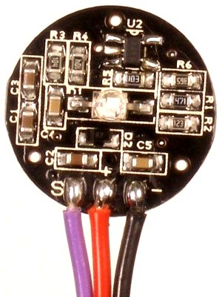 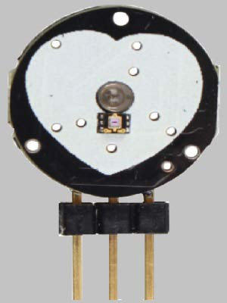 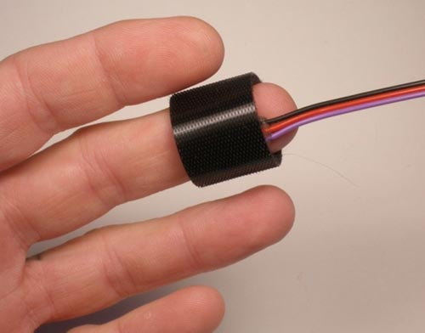

### ****LM35 Temperature Sensor**: **LM35**** is a analog linear temperature sensor. Its output is proportional to the temperature (in degree Celsius). The operating temperature range is from -55°C to 150°C. The output voltage varies by 10mV in response to every oC rise or fall in temperature. It can be operated from a 5V as well as 3.3 V supply and the stand by current is less than 60uA.

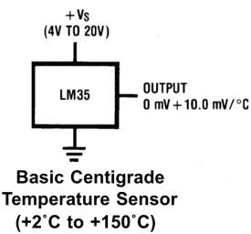

### ****ESP8266-01:**** Most people call ESP8266 as a WIFI module, but it is actually a microcontroller. ESP8266 is the name of the microcontroller developed by Espressif Systems which is a company based out of shanghai. This microcontroller has the ability to perform WIFI related activities hence **it is widely used as a WIFI module**.

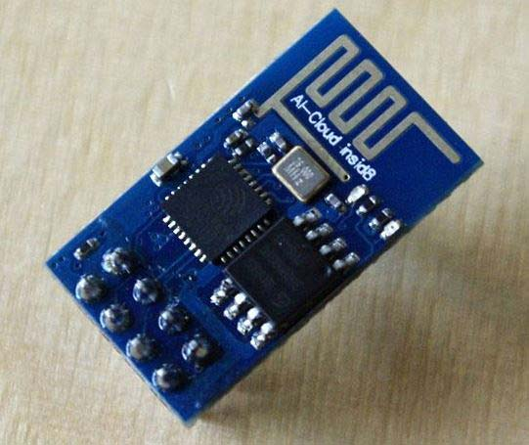

### ****CIRCUIT DIAGRAM****

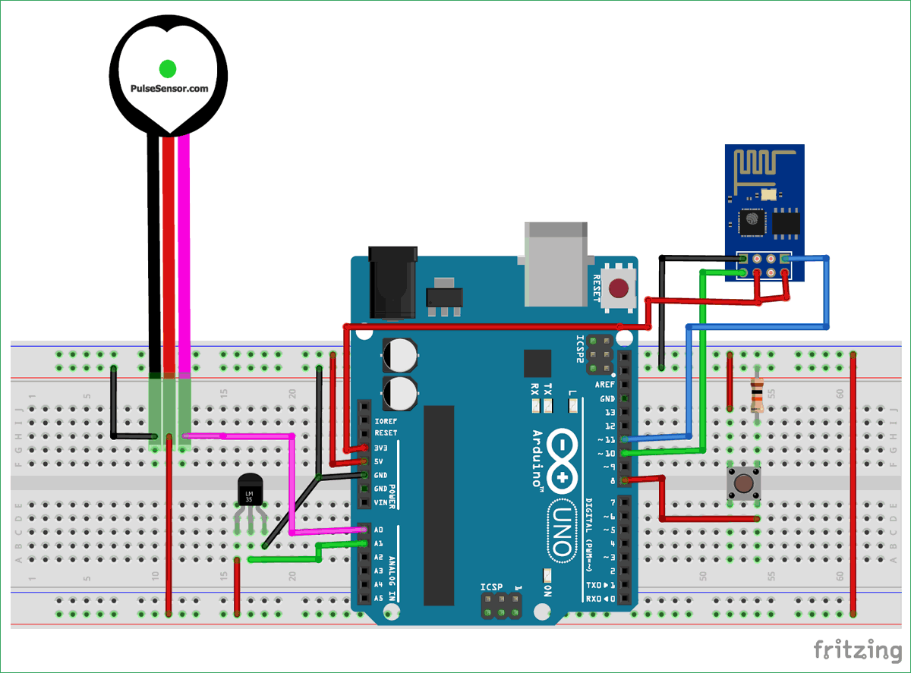

Below are the connections:

* **Signal pin of pulse sensor -> A0 of arduino**
* **Vcc pin of pulse sensor -> 5V of arduino**
* **GND pin of pulse sensor -> GND of arduino**
* **Vout of LM35 -> A1 of Arduino**
* **Tx of ESP8266 -> pin 10 of arduino**
* **Rx of ESP8266 -> pin 11 of arduino**
* **CH_PD and Vcc of ESP8266 -> 3.3 V of arduino**
* **GND of ESP8266 -> GND of arduino**
* **Push button ->  digital pin 8 of arduino**

### ****METHODOLOGY****

### ****Configuring ThingSpeak to record Patient Data online****

[ThingSpeak](https://thingspeak.com/) provides very good tool for [IOT based projects](http://circuitdigest.com/internet-of-things-iot-projects). By using ThingSpeak site, we can monitor our data and control our system over the Internet, using the Channels and webpages provided by ThingSpeak. ThingSpeak **‘Collects’** the data from the sensors, **‘Analyze and Visualize’** the data and **‘Acts’** by triggering a reaction. We have previously used ThingSpeak in [Weather station project using Raspberry Pi and using Arduino](http://circuitdigest.com/microcontroller-projects/raspberry-pi-iot-weather-station-to-monitor-temperature-humidity-pressure), check them to learn more about ThingSpeak. Here we are briefly explaining to use ThingSpeak for this **IOT Patient Monitoring Project.**

We will use **ThingSpeak** to monitor patient heartbeat and temperature online using internet. We will also use**IFTTT** platform to connect ThingSpeak to email/message service so that alert message can be sent whenever the patient is in critical state.

***Step 1:-******First of all, user needs to Create a Account on ThingSpeak.com, then******Sign In and click on Get Started****.*



***Step 2:-  Now go to the ‘Channels’ menu and click on New Channel option on the same page for further process.***

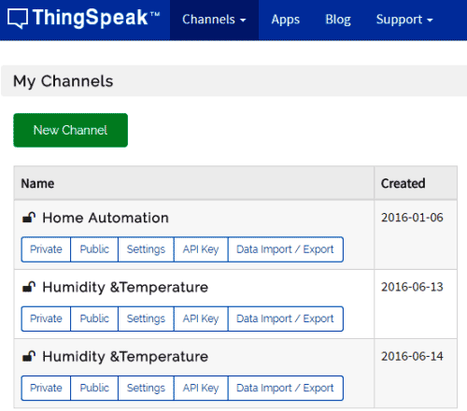

***Step 3:- Now you will see a form*** *for****creating the channel, fill in the Name and Description as per your choice. Then fill ‘Pulse Rate’, ‘Temperature’ and ‘Panic’ in Field 1, Field 2 and Field 3 labels, tick the checkboxes for the Fields. Also tick the check box for ‘Make Public’ option below in the form and finally Save the Channel. Now your new channel has been created.***

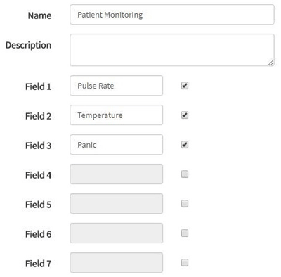

***Step 4:- You will see three charts as shown below. Note the Write API key, we will use this key in our code.***

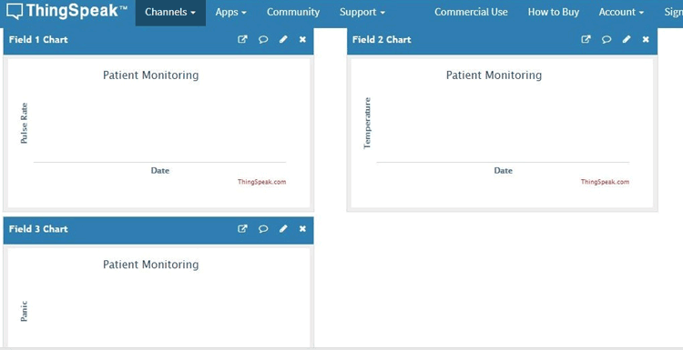

***Step 5:- Now, we will use ThingHTTP app of the server to trigger the IFTTT applet for data entry to Google sheets and send email/sms. ThingHTTP enables communication among devices, websites, and web services without having to implement the protocol on the device level. You can specify actions in ThingHTTP, which you want to trigger using other ThingSpeak apps such as React.***

***To make New ThingHTTP, we will need URL for triggering which we will get from IFTTT.***

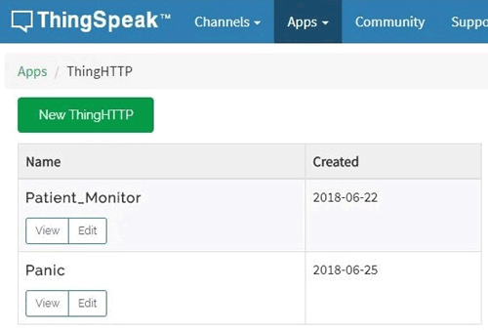

### ****Configuring IFTTT for triggering Mail/SMS based on ThingSpeak Values****

***Step 1:- Login to IFTTT and search for Webhooks and click on it.***

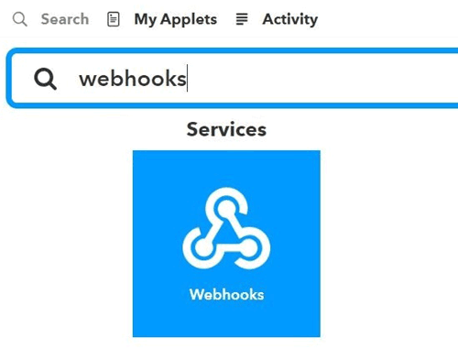

***Step 2:- Click on Documentation.***

***Step 3:- Type “Patient_Info” in the event box and copy the URL. We will use this URL in ThingHTTP.***

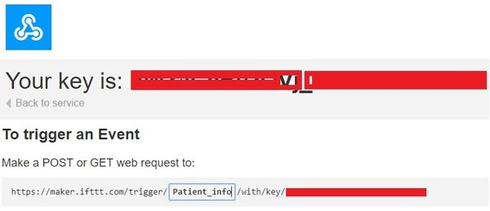

***Step 4:-*Click on New Applete *in* My Applete*option***



***Step 5:- Click on “+this” and search for Webhooks and click on it. Choose trigger as “Receive a web request***”.

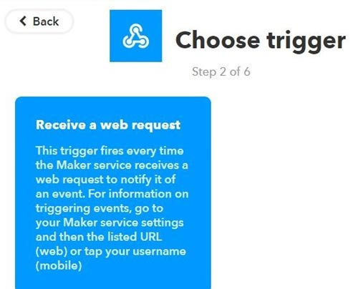

***Step 6:- Click on “+that” and search for Google Sheets and click on it.***

***Click on Add row to spreadsheet.***

***Step 7:- Give any name to your sheet. In formatted row box, you have date and time, event name, BPM value and body temperature*** ***which will be written as shown***.

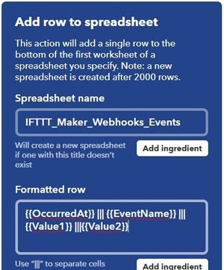

***Step 9:- Review your applet and click on finish.***

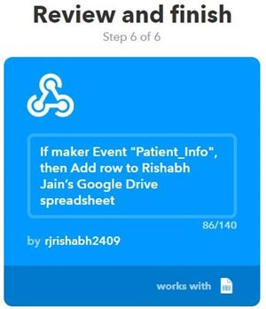

### ****Arduino Code Explanation****

**Complete Arduino code** is given at the end, here we are explaining few important part of it. We will use **library for Pulse rate sensor** which can be downloaded from this [Link](https://github.com/WorldFamousElectronics/PulseSensorPlayground). Also, we are using timer to set interval to take readings. For this we need **Timer library**, which can be downloaded from this [Link](https://github.com/JChristensen/Timer).

Let’s jump to coding part…

First, we include all the libraries. We are using software serial to communicate with esp8266.

**#include <SoftwareSerial.h>**

**#include "Timer.h"**

**#include <PulseSensorPlayground.h> //pulse sensor library**

Make instance for timer, SoftwareSerial and pulse sensor to use in our code.

**Timer t;**

**PulseSensorPlayground pulseSensor;**

**SoftwareSerial esp8266(10,11); //Rx,Tx**

Set-up low-level interrupts for most accurate BPM match and enable DEBUG to show ongoing commands on serial monitor.

**#define USE_ARDUINO_INTERRUPTS true**

**#define DEBUG true**

Set your WiFi name , password and IP of thingspeak.com

**#define SSID "*********" // "your WiFiname"**

**#define PASS "**********" // "wifi password"**

**#define IP "184.106.153.149" // thingspeak.com ip**

Declare String to update information on ThingSpeak channel. You will need API key for this, which can be found from your ThingSpeak channel-> API key . Copy **Write API key** and paste here.

**String msg = "GET /update?key=Your Api Key";**

In setup function, set the baud rate for serial communication between Arduino serial monitor and esp8266. Start the ESP communication by giving AT command to it and connect it by calling connectWiFi(); function. After that we will initialize Timers by calling t.every(time_interval, do_this);which will take the readings of the sensors and update on the channel after every time_interval you defined.

**void setup()**

**{**

**Serial.begin(9600);**

**esp8266.begin(115200);**

**pulseSensor.analogInput(PulseWire);**

**pulseSensor.blinkOnPulse(LED13);** //auto-magically blink Arduino's LED with heartbeat.

**pulseSensor.setThreshold(Threshold);**

// Double-check the "pulseSensor" object was created and "began" seeing a signal.

**if (pulseSensor.begin()) {**

**Serial.println("We created a pulseSensor Object !");**

**}**

**Serial.println("AT");**

**esp8266.println("AT");**

**delay(3000);**

**if(esp8266.find("OK"))**

**{**

**connectWiFi();**

**}**

**t.every(10000, getReadings);**

**t.every(10000, updateInfo);**

**}**

Make function for connectWiFi() which will return True or False depending upon Wi-Fi connected or not**. AT+CWMODE=1**will make ESP8266 work in station mode. **AT+CWJAP=\,** command, used in this function, is to connect to your Access Point (your Wi-Fi router).

**boolean connectWiFi()**

**{**

**Serial.println("AT+CWMODE=1");**

**esp8266.println("AT+CWMODE=1");**

**delay(2000);**

**String cmd="AT+CWJAP=\"";**

**cmd+=SSID;**

**cmd+="\",\"";**

**cmd+=PASS;**

**cmd+="\"";**

**Serial.println(cmd);**

**esp8266.println(cmd);**

**……**

**…..**

Make getReadings(); function to take pulse sensor and LM35 readings and convert them to string using dtostrf();function**.**

**void getReadings(){**

**raw_myTemp = analogRead(A1);**

**Voltage = (raw_myTemp / 1023.0) * 5000; // 5000 to get millivots.**

**tempC = Voltage * 0.1; //in degree C**

**myTemp = (tempC * 1.8) + 32; // conver to F**

**Serial.println(myTemp);**

**int myBPM = pulseSensor.getBeatsPerMinute(); // Calls function on our pulseSensor object that returns BPM as an "int".**

**if (pulseSensor.sawStartOfBeat()) { // Constantly test to see if "a beat happened".**

**Serial.println(myBPM); // Print the value inside of myBPM.**

**}**

**delay(20);**

Define char array for BPM and temp and convert float value of these sensors to String using **dtostrf().**

**char buffer1[10];**

**char buffer2[10];**

**BPM = dtostrf(myBPM, 4, 1, buffer1);**

**temp = dtostrf(myTemp, 4, 1, buffer2);**

**}**

Make function for updating sensor information on the ThingSpeak channel.

**"AT+CIPSTART=\"TCP\",\"",**AT Command will establish TCP command over port 80

**void updateInfo()**

**{**

**String cmd = "AT+CIPSTART=\"TCP\",\"";**

**cmd += IP;**

**cmd += "\",80";**

**Serial.println(cmd);**

**esp8266.println(cmd);**

**delay(2000);**

**if(esp8266.find("Error"))**

**{**

**return;**

**}**

Attach the readings with the GET URL using "&field1="; for pulse readings and "&field2="; for temperature readings. Send this information using “AT+CIPSEND=” command.

**cmd = msg ;**

**cmd += "&field1="; //field 1 for BPM**

**cmd += BPM;**

**cmd += "&field2="; //field 2 for temperature**

**cmd += temp;**

**cmd += "\r\n";**

**Serial.print("AT+CIPSEND=");**

**esp8266.print("AT+CIPSEND=");**

**Serial.println(cmd.length());**

**esp8266.println(cmd.length());**

**if(esp8266.find(">"))**

**{**

**Serial.print(cmd);**

**esp8266.print(cmd);**

**}**

**…**

**…**

Similarly, make function for panic_button. When button goes to HIGH, esp8266 send the information to the server using AT+CIPSTART and AT+CIPSEND commands.

**void panic_button(){**

**panic = digitalRead(8);**

**if(panic == HIGH){**

**Serial.println(panic);**

**String cmd = "AT+CIPSTART=\"TCP\",\"";**

**cmd += IP;**

**cmd += "\",80";**

**Serial.println(cmd);**

**esp8266.println(cmd);**

**…..**

**..**

Attach this information to "&field3=“.

**cmd = msg ;**

**cmd += "&field3=";**

In loop function, call panic_button() and timers using t.update() function .

**void loop()**

**{**

**panic_button();**

**start: //label**

**error=0;**

**t.update();**

**……**

**……**

**Cost :**

**Rs 2000/- Overall.**

**CONCLUSION**

n this study, we presented some of the background information related to the

development of the elderly healthcare monitoring system with IoT. As stated, the

primary objective of this research will be concerned itself with the development of

ambient assisted elderly healthcare monitoring system with IoT. The developing

system can successfully detect and generate alarms in case of stroke onset, which

will allow the timely delivery of medical assistance, to mitigate the long-term

effects of these attacks. With the use of IoT, wearable healthcare devices collect and

share information effectively in a database system with patient and medical per-

sonnel to make it feasible to make a faster communication and decision about the

emergency situation much more accurately. IoT offers bigger promise in the ﬁeld of

healthcare and rehabilitation, where its smart remote technologies are already going

to be applied to improve access to care, increase the immediateness of care and

most importantly accuracy of the care.

Acknowledgments This work was supported by the National Research Council of Science &

Technology (NST) grant by the Korea government (MSIP) (No. CRC-15-05-ETRI).

Development of the Elderly Healthcare Monitoring System with IoT 313

In this study, we presented some of the outlook of the project related to the development of the elderly healthcare monitoring system with IOT. As stated, the primary objective of this project will be concerned itself with the development of ambient assisted elderly healthcare monitoring system with IOT. The developing system can successfully detect and generate alarms in case of any health abnormality or emergency , which will allow the timely delivery of medical assistance, to mitigate the long-term effects of these circumstances. With the use of IOT, wearable healthcare devices collect and share information effectively in a database system with patient and medical personnel to make it feasible to make a faster communication and decision about the emergency situation much more accurately. IOT offers bigger promise in the ﬁeld of healthcare and rehabilitation, where its smart remote technologies are already going to be applied to improve access to care, increase the immediateness of care and most importantly accuracy of the care.

**REFFERENCES**

1. Mansoor Hussain Shah, Sheroz Khan, Khairul Azami Sidek, Syed Absar Kazmi and Kushsariy Abdul Kadir, "From Measurement of Photoplythsmography signal for Heart Rate Variability and comparison of two different Age Groups", 2015.
2. S. Pradeep Kumar, Vemuri Richard Ranjan Samson, U. Bharath Sai, P L S D. Malleswara Rao and K. Kedar Eswar, "From Smart Health Monitoring System of Patient Through IoT", International conference on I-SMAC, pp. 551-556, 2017.
3. Simone Cirani and Macro Picone, "From Wearable Computing for the Internet of Things", IEEE Computer Society, pp. 35-41, 2015.
4. Aileni Raluca Maria, Sever Pasca and Rodica Strungaru, "From Heart Rate Monitoring by using Non-invasive Wearable Sensor", 6 th IEEE International Conference on E-Health and Bioengineering-EHB , pp. 587-590, 2017.
5. A. Nishitha Reddy, Achsah Mary Marks, S.R.S. Prabaharan and S. Muthulakshmi, "From IoT Augmented Health Monitoring System", 2017 International Conference on Nextgen Electronic Technologies, pp. 251-254.
6. Vaibhavi Bhelkar and D.K. Shedge, "From Different Types of Wearable Sensors and Health Monitoring Systems: A Survey", 2nd International Conference on Applied and Theoretical Computing and Communication Technology (iCATccT), pp. 43-48.
7. Aida Kamisalic, Iztok Fister, Muhamed Turkanovic and Saso Karakatic, "From Sensors and Functionalities of Non-Invasive Wrist-Wearable Devices: AReview", May 2018.
8. L. Y. Mano, B. S. Faiçal, L. H. Nakamura, P. H. Gomes, G. L. Libralon, R. I. Meneguete, et al., "Exploiting IoT technologies for enhancing Health Smart Homes through patient identification and emotion recognition", Computer Communications, vol. 89, pp. 178-190, 2016.
9. Z. Yang, Q. Zhou, L. Lei, K. Zheng and W. & Xiang, "An IoT-cloud based wearable ECG monitoring system for smart healthcare", Journal of medical systems, vol. 40, no. 12, pp. 286, 2016.
10. M. Chen, Y. Ma, J. Song, C. F. Lai and B. & Hu, "Smart clothing: Connecting human with clouds and big data for sustainable health monitoring", Mobile Networks and Applications, vol. 21, no. 5, pp. 825-845, 2016.